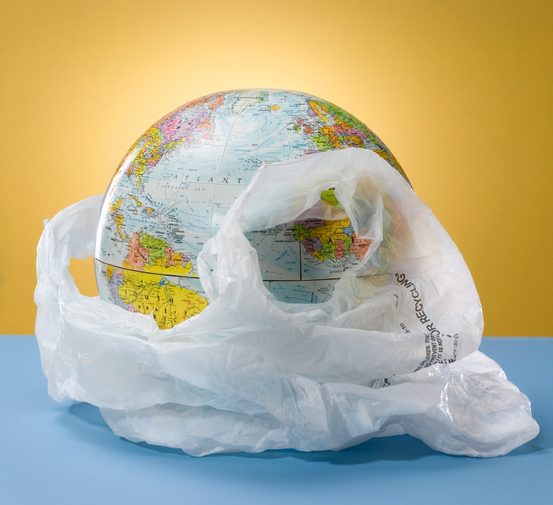

Agenda:
- Guard of honour
- Prayer
- Lighting of lamp
- Floral welcome
- Message by the Principal
- Swagatham
- Hum Hindustani (Nursery)
- Dhimsa (IIIclass)
- Aaja nachle (PP 1)
10. Tiranga pyara (PP 2)
11. Annual report by the Vice Principal
12.Nation builders (Iclass)
13. Message by the Chief Guest
14. Prize distribution I to III class
15. Reject Plastic - ballad (IV and Vclass)
16. Harmony (IIclass)
17. Prize distribution (IV to Xclass)
18. Jungle jungle (IIIclass)
19. Mohikali (IX class)
20. Bihu (III class)
21. Zingaat (VI B )
22. Manipuri Radha (VIII girls)
23. Prize distribution (Special prizes)
24. Karate performance
25. Jalli Kattu (VIII boys)
26. Ghoomar (VII girls)
27. Punjabi Munde (VII boys)
28. Jai Telangana (VI A )
29. Vote of thanks

Kindly carry your water bottle to lessen your use of plastic.
